EXPERIMENT NO: 5

**Name: ATHUL VINAYAKUMAR**

**Roll No: 05 Batch: MCA B Date: 19-04-2022**

**AIM:**

To familiarize with set operations

**QUESTION:**

1. List all the customers who are depositors but not borrowers.

2. List all the customers who are both depositors and borrowers

3. List all the depositors having deposit in all the branches where Sunil is having Account 4. List all the customers living in city NAGPUR and having branch city BOMBAY or   DELHI

5. List all the depositors living in city NAGPUR

6. List all the depositors living in the city NAGPUR and having branch in city BOMBAY 7. List the branch cities of Anil and Sunil

8. List the customers having deposit greater than 1000 and loan less than 10000. 9. List the cities of depositors having branch VRCE.

10. List the depositors having amount less than 1000 and living in the same city as Anil 11. List all the cities where branches of Anil and Sunil are locate

12. List the amount for the depositors living in the city where Anil is living

**PROCEDURE AND OUTPUT**

1. 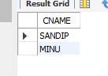SELECT CNAME FROM DEPOSIT WHERE DEPOSIT.CNAME NOT IN (SELECT CNAME FROM BORROW);

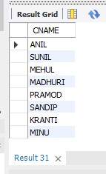2. SELECT CNAME FROM DEPOSIT UNION (SELECT CNAME FROM  BORROW)

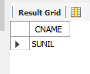3. SELECT D1.CNAME FROM DEPOSIT D1 WHERE D1.BNAME IN(SELECT  D2.BNAME FROM DEPOSIT D2 WHERE D2.CNAME = 'SUNIL' );

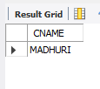4. SELECT C1.CNAME FROM CUSTOMERS C1,DEPOSIT D1, BRANCH B1 WHERE C1.CITY = 'NAGPUR' AND C1.CNAME = D1.CNAME AND D1.BNAME = B1.BNAME AND B1.CITY IN ('BOMBAY','DELHI');

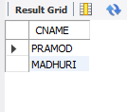5. SELECT Distinct(CUSTOMER.CNAME) from CUSTOMER,DEPOSIT WHERE City='NAGPUR';

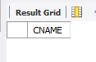6. SELECT C1.CNAME FROM CUSTOMERS C1,DEPOSIT D1, BRANCH B1 WHERE C1.CITY = 'NAGPUR' AND C1.CNAME = D1.CNAME AND D1.BNAME = B1.BNAME AND B1.CITY IN ('BOMBAY');

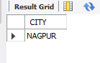7.  SELECT B1.CITY FROM DEPOSIT D1, BRANCH B1 WHERE D1.BNAME =  B1.BNAME AND D1.CNAME IN ('SUNIL' ,'ANIL');

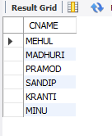8.  SELECT DISTINCT D1.CNAME FROM deposit D1, borrow B1 WHERE  D1.AMOUNT>1000 AND B1.AMOUNT<10000;

9.  SELECT B1.CITY FROM deposit D1, branch B1 WHERE D1.BNAME=B1.BNAME  AND B1.BNAME='VRCE';

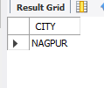

10.

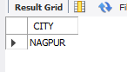11.  SELECT B1.CITY FROM BRANCH B1 WHERE B1.BNAME IN (SELECT  D1.BNAME FROM DEPOSIT D1 WHERE D1.CNAME IN ('ANIL','SUNIL'));

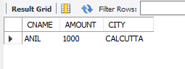12. SELECT DISTINCT(D1.CNAME),D1.AMOUNT ,C1.CITY FROM deposit D1, CUSTOMERS C1, BRANCH B1 WHERE D1.CNAME=C1.CNAME AND C1.CITY IN(SELECT C2.CITY FROM customer C2 WHERE C2.CNAME='ANIL');